36.48: Smallest resolving angle is for short-wavelength light(400 nm)
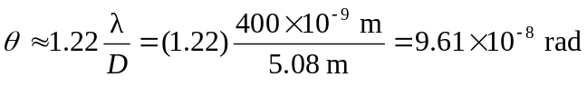

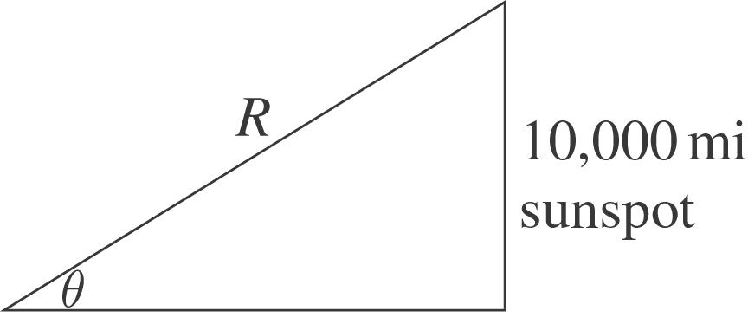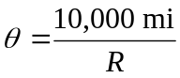

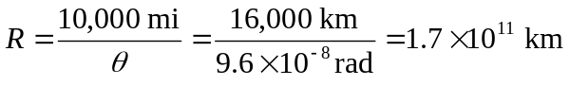
This is less than a light year, so there are no stars this close.

